 |  | 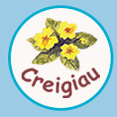 | 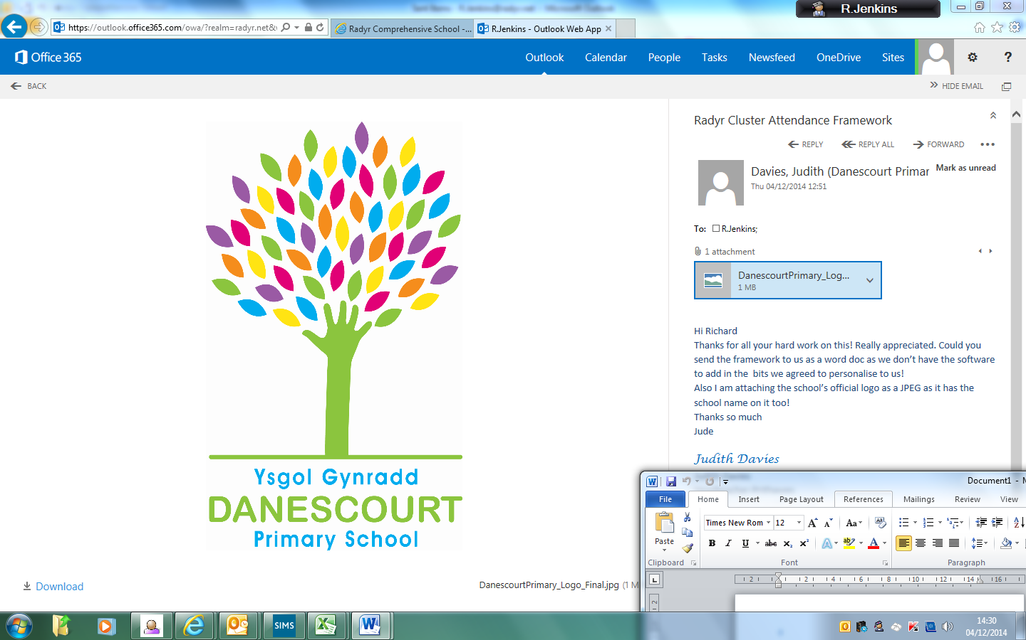 | 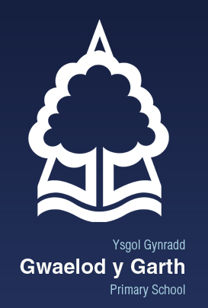 |  |  | 

Leave of Absence Form

I request permission to take the following child / children out of school:

Name: ………………………………………………………………………………………… Class: ……………………………………………………

Name: ………………………………………………………………………………………… Class: ……………………………………………………

Name: ……………………………………………………………………………………….. Class: ……………………………………………………

Schools within the Radyr Primary Cluster will authorise one family holiday, during term time, of up to five days. This authorisation is subject however, to the child’s attendance over the previous 12 months hitting the minimum threshold of 95%.

I understand that under the terms of the Education (Penalty Notices-Wales) Regulations 2013, Local Authorities have been given powers to issue Fixed Penalty Notices (FPNs) as an alternative to taking legal action against parents/carers when responding to absenteeism from school.

Reason for absence (please give full details in the box provided and any other documentary evidence to support this request):

……………………………………………………………………………………………………………………………………………………………………………………………………………………………………………………………………………………………………………………………………………………………………………………………………………………………………………………………………………………………………………………………………………………………………………………………………………………………………………………………………………………………………………………………………………………………………………………………………………………………..
………………………………………………………………………………………………………………………………………………………………………………………………………………………………………………………………………………………………………………………………………………………………………………………………………………
………………………………………………………………………………………………………………………………………………………………………………………………………
Dates of absence:

From (day, date, month) ……………………………………………………….. to (day, date, month) ………………………………………………………………….

Parent Name: ……………………………………………………………….Signed: ………………………..…………………………… Date: …………………………….

FOR SCHOOL USE ONLY:

Attendance over the past 12 months: ……………………………………………

□ Permission is not authorised for the above named child / children to have leave of absence.

□ Permission is authorised for the above named child / children to have leave of absence for 5 days only, as the attendance is above 95%.

Attendance Officer: Name: ……………………………………………… Signed: ………………………………………………Date:……………………

