21st May 2026

Dear Parents / Carers
As part of our whole‑school learning theme, Get Connected, we are launching a fun and meaningful challenge to help families spend more quality time together and reduce unnecessary screen time. Introducing our Digital Lockbox Competition.
We are inviting families to create a special box where devices can “take a break” during important moments such as mealtimes, games nights or reading together. Your lockbox can be as creative and imaginative as you like, using materials you already have at home — a shoebox, biscuit tin, cereal box or even a decorated jar.
Here are a few simple ideas to inspire you:
• Shoebox makeover with wrapping paper, comics, stickers or drawings
• Treasure chest with painted cardboard and a paper “padlock”
• Family photo box decorated with pictures of special moments
• Superhero or fantasy box such as a dragon’s cave or magical chest
• Kindness box covered in positive messages or family values
Once your lockbox is ready, please share a photo with your child’s class teacher (either physically or via the Google Classroom) or email it to the school office. You are also welcome to include any Digital Family Promises you’ve made together, such as “No phones at dinner” or “Screens off after 7.00 pm”.
A prize will be awarded to the family who shows a real commitment to strengthening connections and building healthier digital habits. This will be selected by the Digital Leaders from the picture we receive. Entries will be judged on Tuesday 9th June.
We can’t wait to see your creative ideas and the thoughtful promises you make as a family. Thank you for supporting this initiative and helping us stay truly connected.
Warm regards,
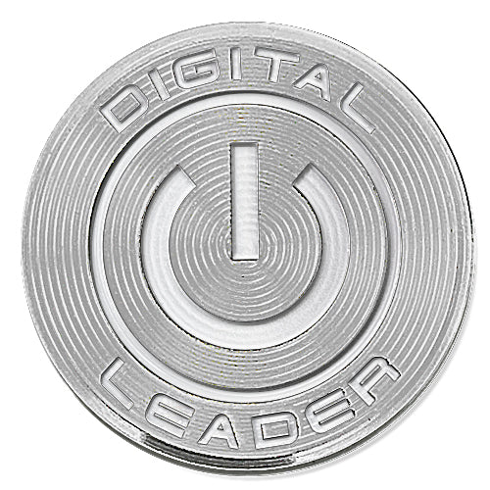
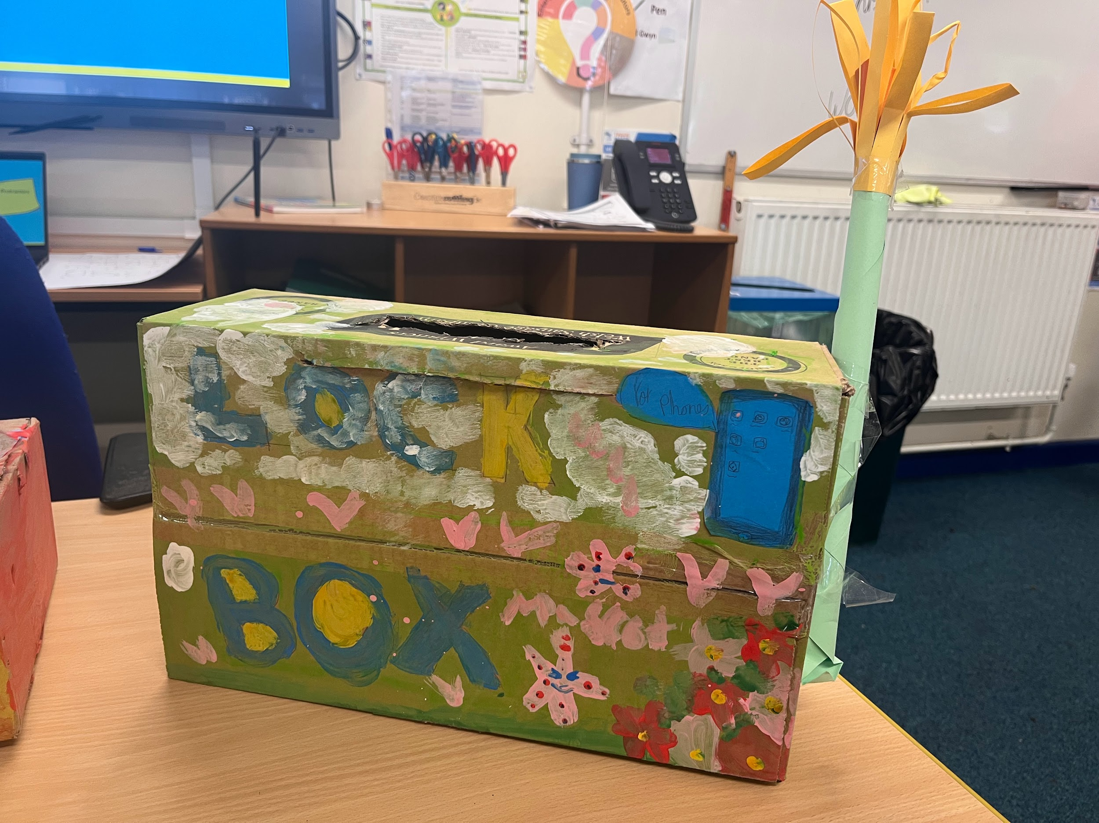
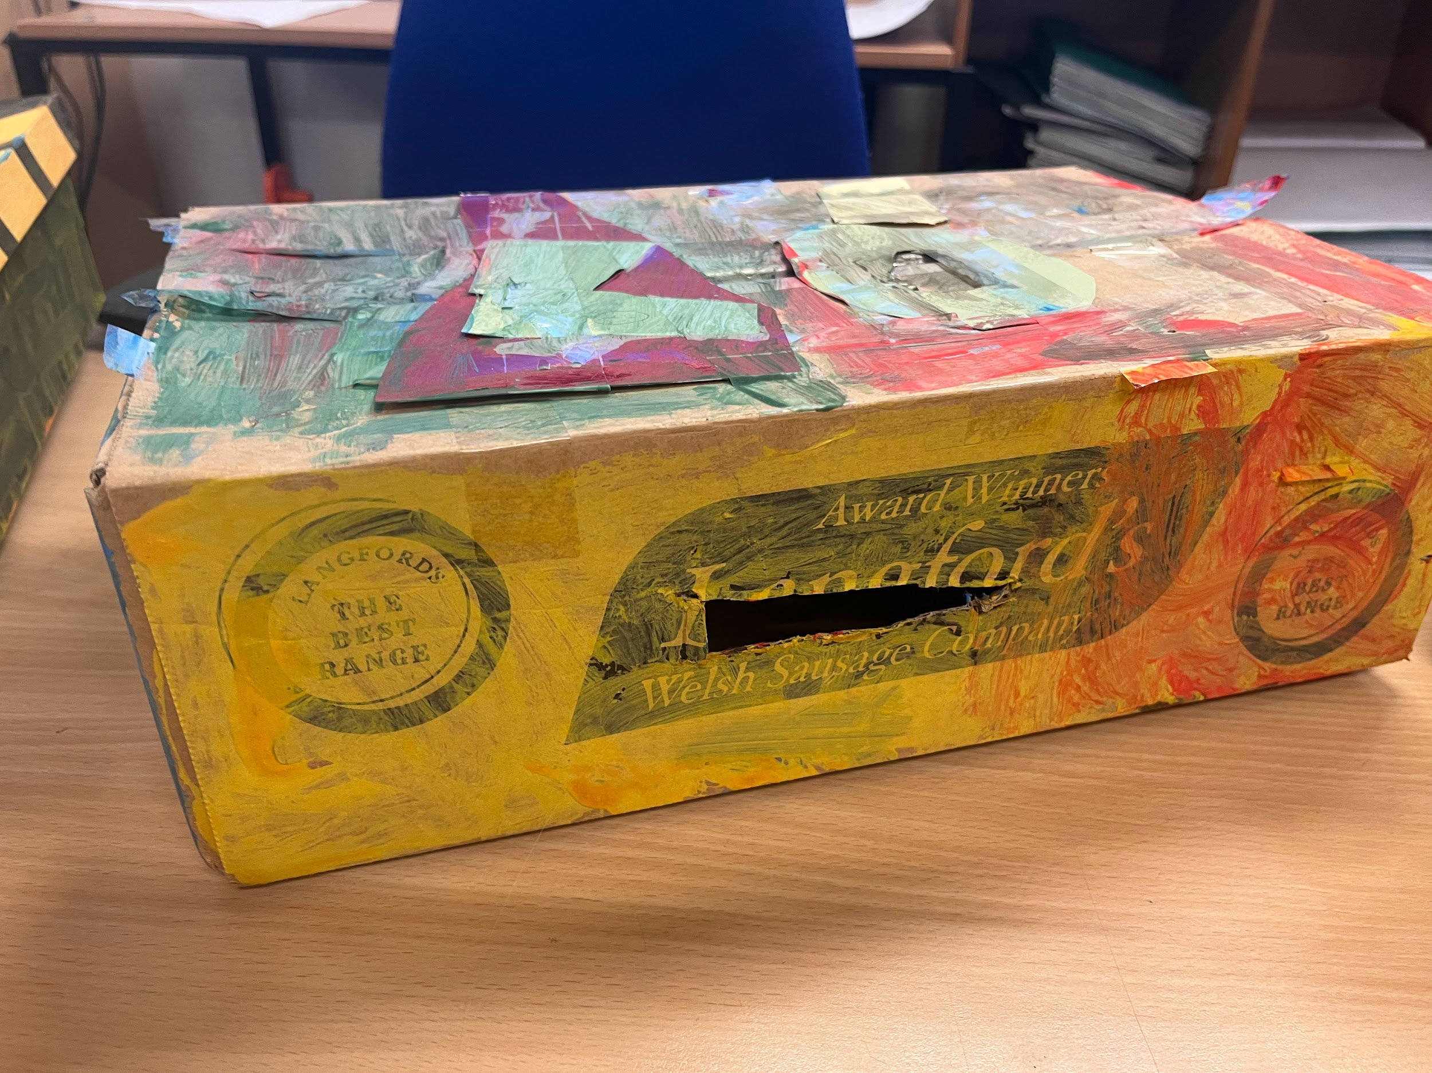
Mr Howard and The Digital Leaders

